ACKNOWLEDGEMENT

This report would not have been published without the guidance and assistance of several people who always provide a good solution and extended their valuable assistance in preparing and implementing this project.

First of all, I would like to express our deepest gratitude to **Dr. PO Kimtho**,director of the Institute of Technology of Cambodia, for his good cooperation with the partner universities at the local, regional, and international levels, to enhance the quality of the training of engineers and senior technicians.

Secondly, I would like to thank **MR. LAY Heng**, Head Department of Information Communication Engineering, for his management, vision, and efficient policy to develop a better quality of education in the department and his guidance to efficiently finish the thesis.

Thirdly, I would also like to acknowledge **Mr. SOK Kimheng**, my supervisor of the internship and project management for the time he has devoted to me during this period for giving the solutions, ideas, and technical. I also greet him for his remarks and corrections which allow me to write our final dissertation.

Very special thanks to all teachers in the Information of Communication Engineering department for the knowledge they have given me plenty of value.

Finally, I would like to express my profound gratitude to my parents for their unfailing support and continuous encouragement in my life to successfully achieve my higher study. It could not have been possible without them.

មូលន័យសង្ខេប

ក្នុងអំឡុងកពេលធ្វើកម្មសិក្សារយះពេល៣ខែ បន្ទាប់ពីបានបញ្ចប់ការសិក្សាឆ្នាំទី៥របស់ខ្ញុំនៅវិទ្យាស្ថានបច្ចេកវិទ្យាកម្ពុជា គ្រប់សិស្សានុសិស្សទាំងអស់រួមទាំងខ្ញុំផងដែរគឺមានកាតព្វកិច្ចត្រូវចុះកម្មសិក្សាក្នុងគោលបំណងធ្វើការអនុត្តជាក់ស្តែងនូវអ្វីដែលខ្ញុំបានសិក្សានៅសាលាកន្លងមក។ របាយការណ៍នេះបានផ្តល់ឱ្យមាននូវព័ត៍មានលំអិតនៃការ​ចុះកម្មសិក្សារបស់ខ្ញុំនៅវិទ្យាស្ថានបច្ចេកវិទ្យាកម្ពុជា ៣ខែ ដែលបានធ្វើឡើងចាប់ពីថ្ងៃទី​ ១៣​ ខែកុម្ភះ ឆ្នាំ២០២២ ដល់ថ្ងៃទី ១៣​ ខែឧសភា ឆ្នាំ២០២៣។​​ ប្រធានបទកម្មសិក្សារបស់ខ្ញុំគឺ **ប្រព័ន្ធ** ដែលជាប្រព័ន្ធមួយសំខាន់ ដែលប្រើនៅក្នុងសាលាដែលបានបង្កើតឡើងក្នុងគោលបំណងដើម្បីផ្តល់នូវគេហទំព័រមួយសម្រាប់ការគ្រប់គ្រង់ដំណើរការចុះឈ្លោះសិស្សនិសិត្សដែលចូលបណ្ណាល័យ។

**ប្រព័ន្ធ​** គឺជាគេហទំព័រមួយដែលត្រូវបានបង្កើតឡើងក្នុងគោលបំណងផ្តល់នូវមុខងារសំខាន់ៗ ដែលអនុញ្ញាតិឱ្យអ្នកប្រើប្រាស់អាចគ្រប់គ្រង់ទិន្នន័យបេក្ខជនទាំងអស់ដោយសំរួលការរក្សារទុក្ខជាក្រដាស់។ មួយវិញទៀតអ្នកប្រើប្រាស់អាចត្រួតពិនិត្យការចុះឈ្មោះរបស់និសិត្សជាប្រចាំថ្ងៃ និងអាចធ្វើការទាញយកទិន្នន័យសិស្សនិសិត្សជារបាយការណ៍ និងក្រាហ្វ។ មិនត្រឹមតែប៉ុណ្ណោះអ្នកប្រើប្រាស់អាចធ្វើការរក្សាទុក្ខព័ត៌មានសៀវភៅទៅតាមទីកន្លែង និងតាមដេប៉ាតឺម៉ង់បានផងដែល។ លើសពីនេះក៏អាចបញ្ចូលទិន្នន័យជាឯកសារ Excel បានផងដែរ។

គម្រោងនែកម្មវិធីគេហទំព័រមួយនេះត្រូវបាយអនុវត្តនៅក្នុងភាសាសរសេរកម្មវិធី Node JS ដោយប្រើប្រាស់ហ្វ្រេមវើក (Framework) Express JS។ សម្រាប់ការគ្រប់គ្រងទិន្នន័យនៃប្រព័ន្ធនេះត្រូវបានអនុវត្តជាមួយជាមួយ MYSQL និង សម្រាប់ខាងផ្នែកការបង្ហាញទៅកាន់អ្នកប្រើប្រាស់ត្រូវបានអនុវត្តជាមួយ Vue JS។

ជាលិទ្ធផលនៃការចុះកម្មសិក្សានេះ បច្ចុប្បន្ននេះកំពុងស្ថិតក្នុងការអភិវឌ្ឍន៍បន្ថែមដើម្បីអោយកាន់តែប្រសើរមុន។ ហើយគេហទំព័រនិងដាក់ប្រើប្រាស់ជាផ្លូវការក្នុងបណ្ណាល័យឆាប់ៗ។

RÉSUMÉ

Pendant le stage de trois mois après avoir terminé ma cinquième année universitaire à l'Institut de technologie du Cambodge. Tous les étudiants du département d'ingénierie de l'information de la technologie et de la communication et moi-même avons été obligés de faire un stage pour appliquer ce que j'ai appris à l'école dans la pratique. Dans ce rapport, on donne les détails de stage qui commencent du 13 Février jusqu’à 11 Mai 2023 à l'Institut de technologie du Cambodge. Pendant les stages, le projet que s’appelle “ ” dont l’objective est fournir un réseau d’application pour contrôler les candidates information et examiner les candidates quand ils appliquent les stages et travailler dans cette entreprise.

Le système est un projet d'application web développé pour offrir des fonctionnalités utiles aux utilisateurs afin de gérer toutes les informations des étudiants et leur présence lorsqu'ils rejoignent la bibliothèque. Une autre fonctionnalité permet aux utilisateurs de contrôler les données des étudiants chaque jour et de télécharger les informations sous forme de graphiques et de fichiers CSV. De plus, les utilisateurs peuvent stocker des informations sur les livres liées à leur emplacement et à leur département. L'une des principales fonctions du système est de télécharger des informations sur les étudiants à partir d'un fichier Excel.

Ce projet de plate-forme est exécuté en le programme de Node JS avec Express JS Framework utilisation. Pour les bases de données de ce système, ils permettant avec MYSQL et pour Client side I utilisent dans Vue JS.

Le projet suite de ce stage, il est actuellement en cours de développement pour s'améliorer. Et le système sera bientôt officiellement lancé dans la bibliothèque Stem.

ABSTRACT

During the three-month internship after ending my fifth academic year at the Institute of Technology of Cambodia. All students of the Department of Information of Technology and Communication Engineering and I were obliged to undergo an internship to apply what I have learned in school into practice. This report drives into detail of internship which took place between 13 February and 11 May 2023 at the Institute of Technology of Cambodia. The project during the internship concerns the “system” whose object is to provide a web application platform for controlling the candidate information and candidate attendance when they join the stem library.

The system is a web application project developed to provide useful features for users to manage all student information and attendance when joining the library. Another feature allows users to monitor student data each day and download the information as graphs and CSV files. Additionally, users can store book information related to their location and department. One of the main functions of the system is to upload student information from an Excel file.

This web platform project is implemented using the Express JS framework in Node JS language. The system's database is implemented with MYSQL and Vue JS is implemented on the client side.

As a result of this internship, it is current it is currently being further developed for the better. And for the system will be officially launched in the Stem library soon.

INTRODUCTION

As engineering students of the Department of Information and Communication Engineering at ITC, the students are required to take an internship for thesis defending before graduation, so they can apply the knowledge that has learned from school as well as acquire new knowledge both soft and hard skill from a company, organization or somewhere else.

Technology offers us many innovations from day to day, especially smartphones, laptops, and desktops which contain modern browsers. Nowadays, there are several platforms of browser applications in the market like Google Chrome, Microsoft Edge, and Apple Safari that offered the use and develop many types of websites. Through this evolution, during my internship, I decided to develop a website application. Otherwise, I applied knowledge, I got from my adviser, about design patterns to prove the lesson theory.

The year fifth internship required students to hold an acceptable project considered by their adviser. Meanwhile, project management at STEM Library needs a system to help the administrator manage their attendance easier than usual. The system creates for managing users’ information and attendance when they do join the library. Moreover, this application is built using to manage book information related to location and department that is easy to find and put back.

As a result, a project manager has proposed a project on the Web application “system” to meet these constraints to facilitate users to manage their system in STEM Library.

This is the final internship report such a thesis divided into 7 chapters. The first is the general presentation of the internship project and information about the place where I took it to build this application. The second focuses on the internship project presentation that I work on during three months internship. Third is the analysis of project ideas, conception, and design that talk about main functional requirements and optional functional requirements. Fourth talk about technology and tool that I use. The Fifth is focused on project implementation. The last one is the conclusion.

# GENERAL PRESENTATION OF INTERNSHIP

## Introduction

The Institute of Technology of Cambodia (ITC) is a Cambodian Higher Education Institution which was founded in 1964 and supported by cooperation between Cambodia and the former Soviet Union. More than 10000 executive members have graduated from ITC. They are currently working intensely on the economic and social infrastructure development of Cambodia. In 1993, the Cambodian and French governments agreed to renovate ITC to improve the performance of the administration and financial services along with the educational system of the institution and the human resources.

The goal of ITC is to provide students with a high-quality education in the fields of engineering sciences and technologies. Students are provided with technical know-how and skills of analysis which allow integration and evolution in the labor market. To achieve this, academic and international scientific research requires development.

Besides academic activities, ITC contributes to maintaining sustainable development and decreasing the inequalities within society through its internal functioning and opening up to foreign countries and the way their students get admitted.



Figure 1: ITC Logo

## Department of Information and Communication Engineering

The Institute of Technology of Cambodia consists of eight engineering departments, including Information and Communication. Department of Information and Communication Engineering provides training in both fundamental and advanced methods and tools of modern computing. Train engineers and masters in IT who can evolve and adapt to new technologies and methods of computing such as software engineering, mobile, and web application development, databases, networks, Management of Information Systems, multimedia, etc. DICE currently cooperates with foreign universities and also some companies to ensure students will have the opportunities to get scholarships to continue further studies and also work with professionals to gain their experiences.

## Address and contact

* Address: PO Box 86, Russian Conf. Blvd Phnom Penh Cambodia.
* Tel: (+855) 23 880 370
* Email: [**info@itc.edu.kh**](mailto:info@itc.edu.kh)
* Website: <https://itc.edu.kh/>
* Location: Show in *Figure 2*

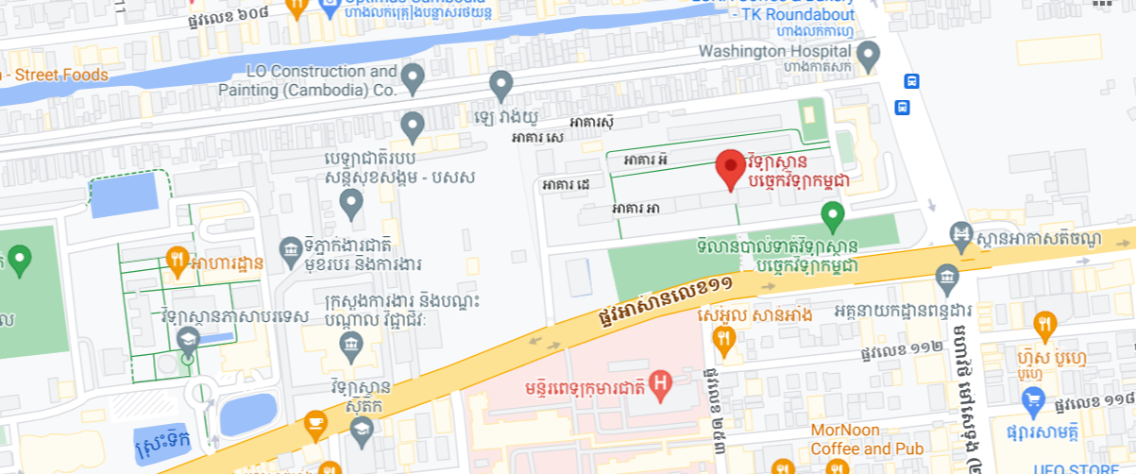

Figure 2: ITC Location

# THE INTERNSHIP PROJECT PRESENTATION

During the internship of three months at ITC, I work on a project called “Library System”, which is a web application developed to manage student information, attendance, and book information. The project is a new project at ITC.

## Structure

The internship and project development was guided and assisted by:

* Academic Supervisor: Mr. SOK Kimheng

Lecturer in the Department of Information and Communication Engineering

* Project Advisor: Mr. SOK Kimheng

Manager Library

## Problem overview

The reason that we propose to build this system is that we found many difficulties whenever there is a new candidate who wants to join the library.

* The attendance register is using Excel difficult to input and increase rows.
* Difficult to keep historical records of candidates after they join the library
* Cannot export data daily, weekly, monthly, and yearly
* Cannot manage student information and their payments every year
* Wasted time finding books for students borrow and to put them back in position

## Objective

To develop a web application called “Library System” to solve many problems such as:

* Accurate attendance tracking: an automated system can accurately record the attendance of students visiting the library.
* Can export student library cards that have a barcode easy to scan when they join the library.
* It can calculate the total of students visiting the library daily, weekly, monthly, and yearly
* Analysis attendance data: can provide a good usage to export data by select date. Can make decisions regarding exporting Excel and bar charts.

## Software development life cycle

### Waterfall

As shown in Figure 3, to realize a project, it is necessary to carefully choose a great and suitable development methodology. As a result, the Waterfall methodology was chosen for developing this project, because the project is respectful to an approach, define-before-design, and design-before-code. Moreover, the methodology works well on this project with limited development time.

* Requirement: I had to understand the objective, functionalities, and what needs to be designed.
* Design: for this stage, I studied the requirement specification and prepare for the system design.
* Implementation: the whole web application was divided into tasks where each of which needed to be finished by coding and testing
* Verification: all of the tasks were integrated to get a complete application. And the web application is needed to do testing to find out about the errors or flaws.
* 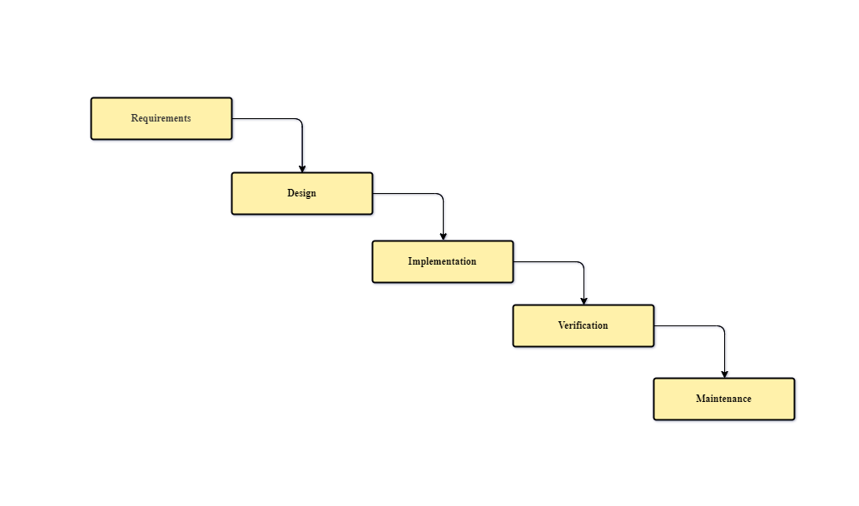Maintenance: as a web developer, I have to check the report from the user and fix the error that has occurred.

Figure 3: Waterfall methodology

## Planning

|  |  |  |  |  |  |  |  |  |  |  |  |  |  |
| --- | --- | --- | --- | --- | --- | --- | --- | --- | --- | --- | --- | --- | --- |
| **Tasks** | **Weeks** | | | | | | | | | | | | |
| 1 | 2 | 3 | 4 | 5 | 6 | 7 | 8 | 9 | 10 | 11 | 12 |
| Get the requirement |  |  |  |  |  |  |  |  |  |  |  |  |
| Define the project scope |  |  |  |  |  |  |  |  |  |  |  |  |
| Wireframing and prototype |  |  |  |  |  |  |  |  |  |  |  |  |
| Implement |  |  |  |  |  |  |  |  |  |  |  |  |
| Testing and Bug Fix |  |  |  |  |  |  |  |  |  |  |  |  |
| Prepare for deployment |  |  |  |  |  |  |  |  |  |  |  |  |

Table 1: Planning table

As shown in Table 1, during my twelfth-week internship at ITC, I spent the first week meeting with clients to gather requirements and define the project scope. After obtaining the project scope, I dedicated two weeks to designing the wireframes and prototypes. Starting from the fourth week, I began implementing the front-end and back-end, which continued until the ninth week. Once I completed the implementation, the client and I conducted testing together to verify the tasks I had accomplished. I spent two weeks resolving bugs and also preparing documents and setting up the environment for deployment and release.

# PROJECT ANALYSIS, CONCEPTION, AND DESIGN

In this section, I begin to identify all the main functional requirements and optional functional requirements of the system.